Seychelles

## Freedom House political status

The data set shows the Freedom House political scores and status of the country each year.

## # A tibble: 19 x 5  
## country iso3c date mean status   
## <chr> <chr> <dbl> <dbl> <chr>   
## 1 Seychelles SYC 1996 3 Partly Free  
## 2 Seychelles SYC 1998 3 Partly Free  
## 3 Seychelles SYC 2000 3 Partly Free  
## 4 Seychelles SYC 2002 3 Partly Free  
## 5 Seychelles SYC 2003 3 Partly Free  
## 6 Seychelles SYC 2004 3 Partly Free  
## 7 Seychelles SYC 2005 3 Partly Free  
## 8 Seychelles SYC 2006 3 Partly Free  
## 9 Seychelles SYC 2007 3 Partly Free  
## 10 Seychelles SYC 2008 3 Partly Free  
## 11 Seychelles SYC 2009 3 Partly Free  
## 12 Seychelles SYC 2010 3 Partly Free  
## 13 Seychelles SYC 2011 3 Partly Free  
## 14 Seychelles SYC 2012 3 Partly Free  
## 15 Seychelles SYC 2013 3 Partly Free  
## 16 Seychelles SYC 2014 3 Partly Free  
## 17 Seychelles SYC 2015 3 Partly Free  
## 18 Seychelles SYC 2016 3 Partly Free  
## 19 Seychelles SYC 2017 3 Partly Free

## Freedom House classification of political change

The data set shows the GDP growth and the ecomic growth classification of the country each year.

## # A tibble: 19 x 4  
## country iso3c date politicalChangeFH  
## <chr> <chr> <dbl> <chr>   
## 1 Seychelles SYC 1996 no change   
## 2 Seychelles SYC 1998 no change   
## 3 Seychelles SYC 2000 no change   
## 4 Seychelles SYC 2002 no change   
## 5 Seychelles SYC 2003 no change   
## 6 Seychelles SYC 2004 no change   
## 7 Seychelles SYC 2005 no change   
## 8 Seychelles SYC 2006 no change   
## 9 Seychelles SYC 2007 no change   
## 10 Seychelles SYC 2008 no change   
## 11 Seychelles SYC 2009 no change   
## 12 Seychelles SYC 2010 no change   
## 13 Seychelles SYC 2011 no change   
## 14 Seychelles SYC 2012 no change   
## 15 Seychelles SYC 2013 no change   
## 16 Seychelles SYC 2014 no change   
## 17 Seychelles SYC 2015 no change   
## 18 Seychelles SYC 2016 no change   
## 19 Seychelles SYC 2017 no change

## Freedom House score trend

The plot shows the Freedom House scores trend of the country.

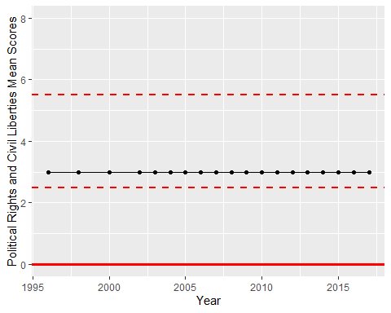

Freedom House Score Trend